Certifications
1) Disability: IN (DOBE - Disability-Owned Business Enterprise)
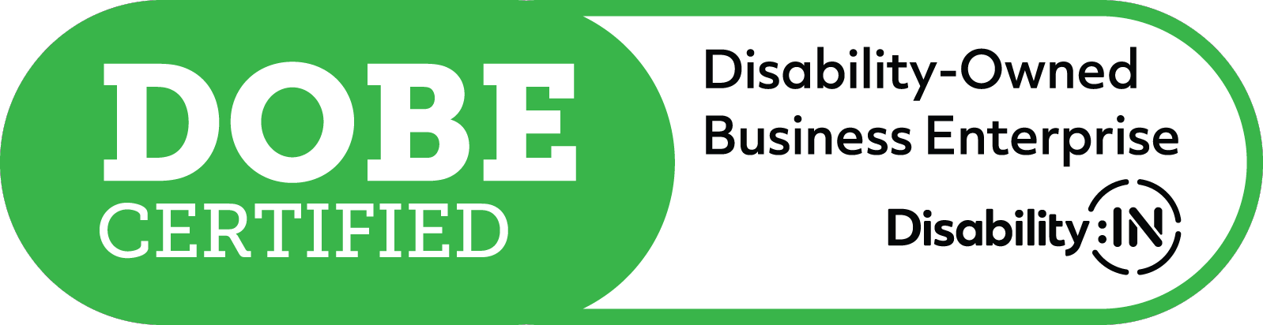Issuing authority: Disability:IN Issued date: Jul 2021
Expires date: Jul 2023
Credential ID: DISABIN28007

2) DFW MSDC-Minority and Woman Owned Business Enterprise – MWBE
Issuing authority: DFW Minority Supplier Development Council
Issued date: Mar 2022
Expires date: Apr 2023
Credential ID: DL02806

3) DFW MSDC-Small Business Enterprise – SBE
Issuing authority: DFW Minority Supplier Development Council
Issued date: Feb 2023
Expires date: Apr 2024
Credential ID: DL02806

4) WBENC-Woman Owned Business Enterprise - WBE- Corporate
Issuing authority: WBENC Issued date: Apr 2014
Expires date: Apr 2024
Credential ID: 2005124423

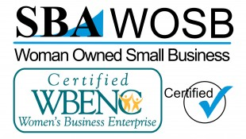5) WBENC-Woman Owned Small Business - WOSB – Federal
Issuing authority: WBENC Issued date: Apr 2014
Expires date: Apr 2024
Credential ID: W040204

6) DLA - Militarily Critical Technical Data Agreement (DD 2345)- Federal
Issuing authority: United States Department of Defense
Issued date: Feb 2017
Expires date: Feb 2022
Credential ID: LLC-6X7E7-38297-MA

7) State of Texas HUB - Historically Underutilized Business
Issuing authority: State of TX Issued date: Oct 2021
Expires date: Oct 2025
Credential ID:1271504222700

8) NY Empire State Development Agency MWBE/MBE - Minority Business Enterprise
Issuing authority: Empire State Development Agency
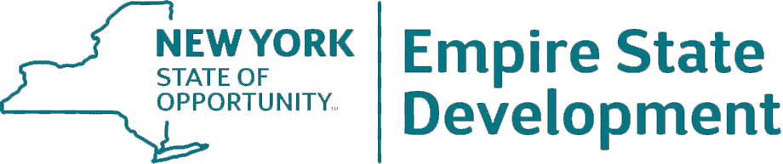Issued date: Apr 2019
Expires date: Apr 2024
Credential ID:64392

9) NY Empire State Development Agency MWBE/WBE - Women Business Enterprise
Issuing authority: Empire State Development Agency
Issued date: Apr 2019
Expires date: Apr 2024
Credential ID:64392

10) New York US DOT/Port Authority DBE - Disadvantaged Business Enterprise
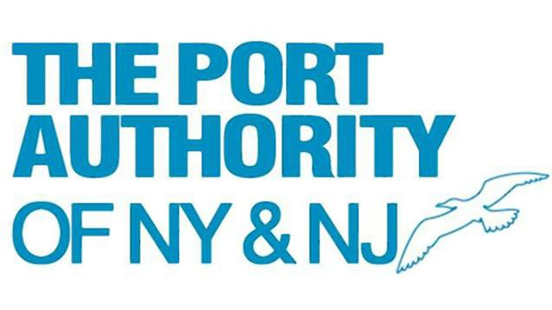Issuing authority: New York US DOT/Port Authority Issued date: Apr 2019
Expires date: Apr 2024
Credential ID: BFDB85014N0421

11) NYC Small Business Services MWBE - Minority and Women owned Business Enterprises Business
Issuing authority: NYC Small Business Services
Issued date: Apr 2019
Expires date: Apr 2023
Credential ID: MWCERT2020-5034

12) NY Nassau County Office of Minority Affairs Minority/Woman-Owned Busines Enterprise
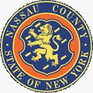Issuing authority: NY Nassau County Office of Minority Affairs
Issued date: Nov 2022
Expires date: Nov 2025
Credential ID: OMA-22-061

13) New Jersey MWBE - Minority and Women owned Business Enterprises Business
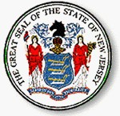Issuing authority: New Jersey
Issued date: Jun 2022
Expires date: Jun 2023
Credential ID: A0255-96

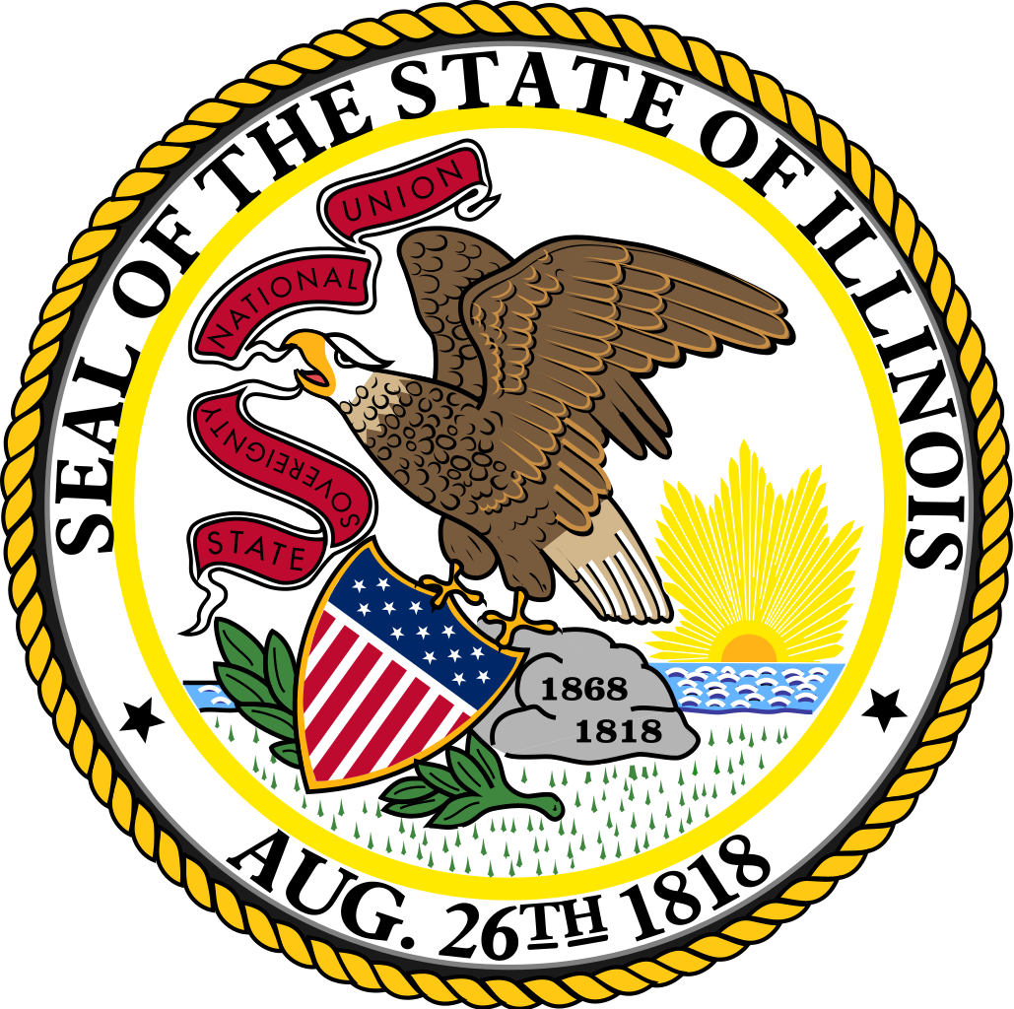14) State of Illinois MWBE/BEP - Business Enterprise Program
Issuing authority: State of Illinois
Issued date: Mar 2019
Expires date: Mar 2024
Credential ID: ----

15) Commonwealth of PA Small Business Enterprise
Issuing authority: Commonwealth of PA Issued date: Nov 2021
Expires date: Nov 2023
Credential ID: 516694202111-SDB-WD

16) Delaware WBE/MBE - Women's Business Enterprise/Minority Business Enterprise
Issuing authority: Delaware - Office of Supplier Diversity
Issued date: Mar 2022
Expires date: Mar 2025
Credential ID: DE22034029

17) Delaware SBF Wholesale - Small Business Focus
Issuing authority: Delaware - Office of Supplier Diversity
Issued date: Mar 2022
Expires date: Mar 2025
Credential ID: DE22034030

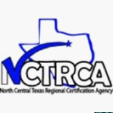18) DBE - Disadvantaged Business Enterprise
Issuing authority: NCTRCA Issued date: Apr 2022
Expires date: Apr 2023
Credential ID: BFDB02026Y0423

19) WBE - Women Business Enterprise
Issuing authority: NCTRCA Issued date: Apr 2021
Expires date: Apr 2023
Credential ID: BFWB70027N0423

20) MBE - Minority Business Enterprise
Issuing authority: NCTRCA Issued date: Apr 2021
Expires date: Apr 2023
Credential ID: BFMB33389N0423

21) City of Austin MOBE - Minority Owned Business Enterprise
Issuing authority: City of Austin
Issued date: May 2021
Expires date: May 2025
Credential ID: V00000918999

22) City of Austin WOBE - Women Owned Business Enterprise
Issuing authority: City of Austin
Issued date: May 2021
Expires date: May 2025
Credential ID: V00000918999

23) Nashville and Davidson County Minority and Women BAO - Business Assistance Office
Issuing authority: Metropolitan Government of Nashville and Davidson County
Issued date: Jun 2022
Expires date: Jun 2023
Credential ID: 23479

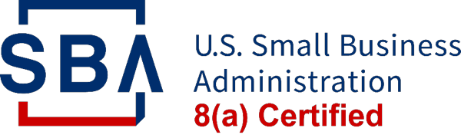24) Small Business Administration 8(a)
Issuing authority: Small Business Administration 8(a) Credential ID: In Process

Licenses

25) TX HHS Wholesale Distributor of Prescription Drugs Issuing authority: Texas Health and Human Services Issued date: Dec 2019
Expires date: Nov 2024
Credential ID: 1000610

26) TX HHS Wholesale Device Distributor
Issuing authority: Texas Health and Human Services
Issued date: Feb 2019
Expires date: Feb 2023
Credential ID: 1000628

